
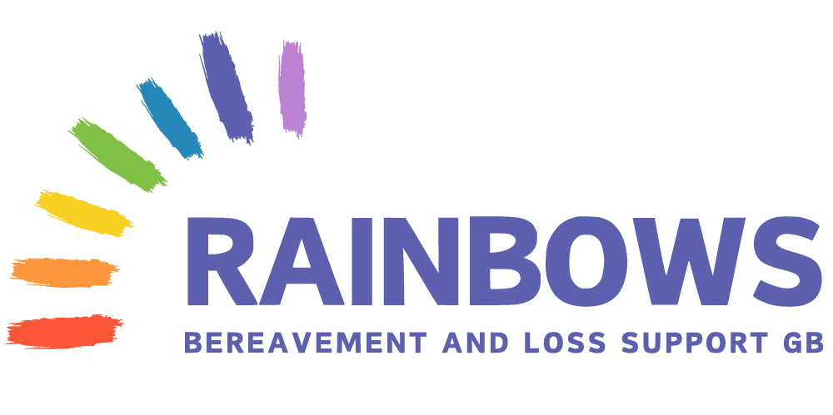
Health and Wellbeing Support Programme:
Through attending the programme, children will have the opportunity to share their worries and anxieties in a safe and non-judgemental way.
It will help them to recognise that we all have feelings and emotions that might make us feel sad and worried and it will give them the chance to develop strategies to help them cope in different situations.
The children will begin to understand that it is ok to have ups and downs and they can learn how to use these emotions to develop greater resilience.
The Health and Wellbeing Programme is an opportunity for children to gather in either a small group or whole class to address concerns associated with health and wellbeing.
The children will participate in at least six sessions which will explore their feelings and worries through stories and engaging activities. The sessions allow them to know that they will be supported by people who care for them.
The closing session allows each participant to create a coping toolbox to collate strategies that they have discovered during the sessions to use when they face difficult times.
To implement the Health and Wellbeing Programme, teachers, classroom assistants and other professionals will lead the activities and guide the discussions to work through the specific topics in each of the sessions.

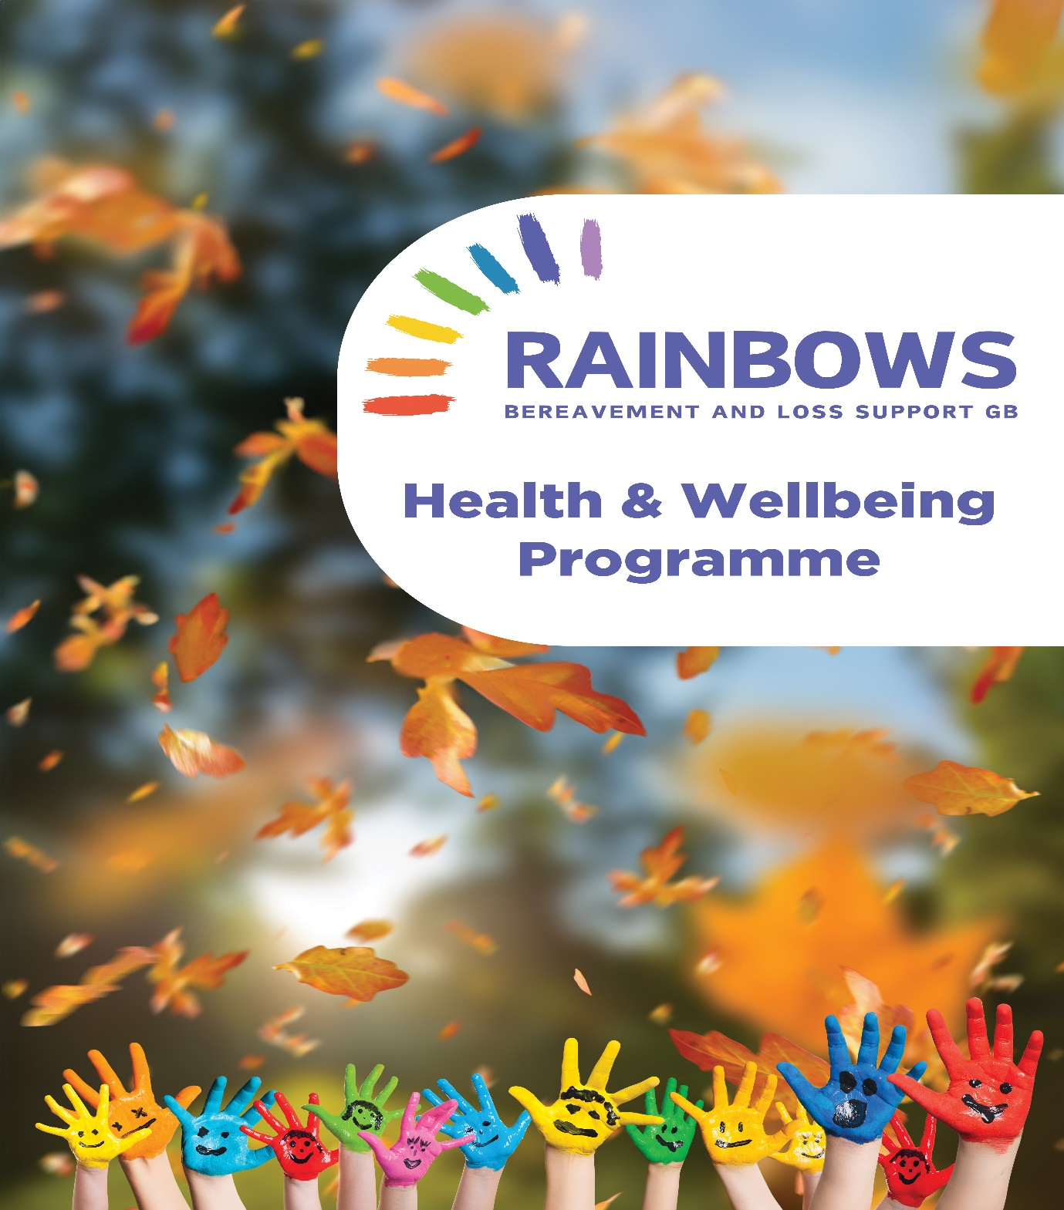
How to order this Programme
Please contact the Resource Centre
Tel: 01616242269
Email rainbowsgb.dc@btconnect.com
Or National Director – Sharon Melia-Craven
Tel: 07764431536
sharonrainbowsgb@btconnect.com
Price Rainbows Schools £75+vat
Non-Rainbows Schools £100+vat

